- To create a ToC using the tools available in Word, you need to ensure you’ve used the proper styles for the document. The image shows the drop-down menu for ToC and the automatic table options (under References tab).
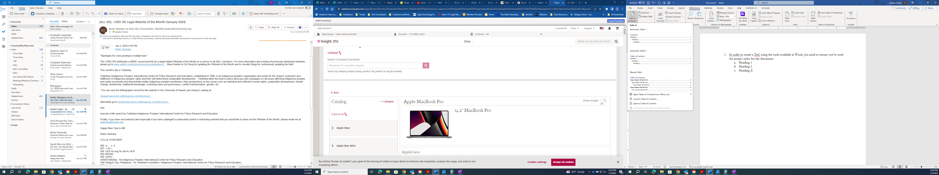

- In styles you’ll find the corresponding terms to match the TOC (under Home tab).
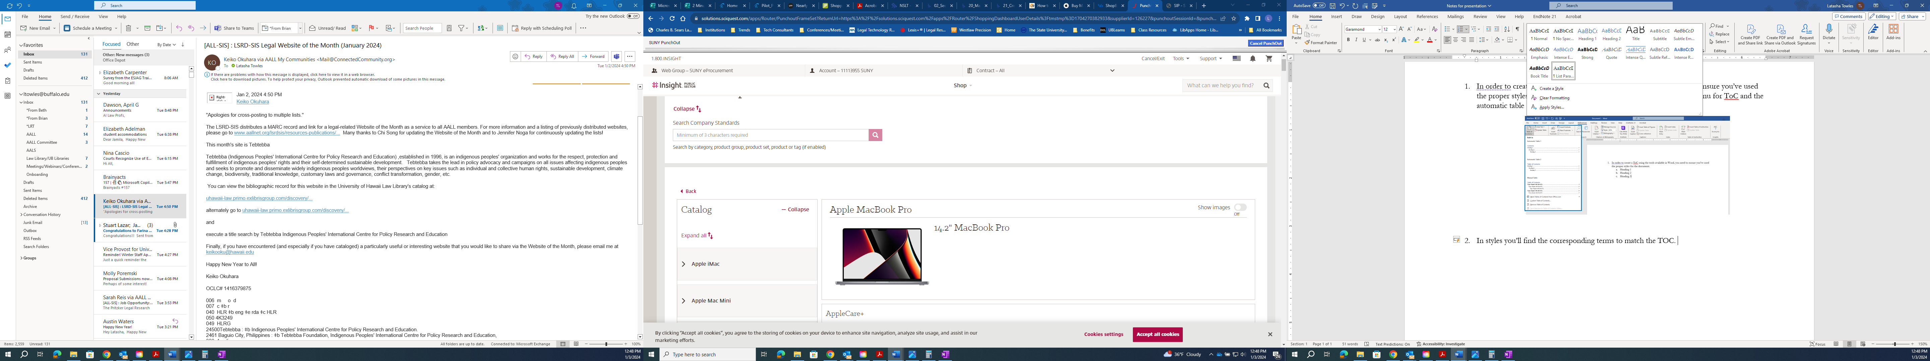

- Check the document to confirm you are using the correct style. Use the Outline or Draft view (under View tab). If a heading you want included in the ToC is labeled ‘Normal’, you’ll need to update the style. It can be updated while in Outline or Draft view by using the styles on the Home tab.
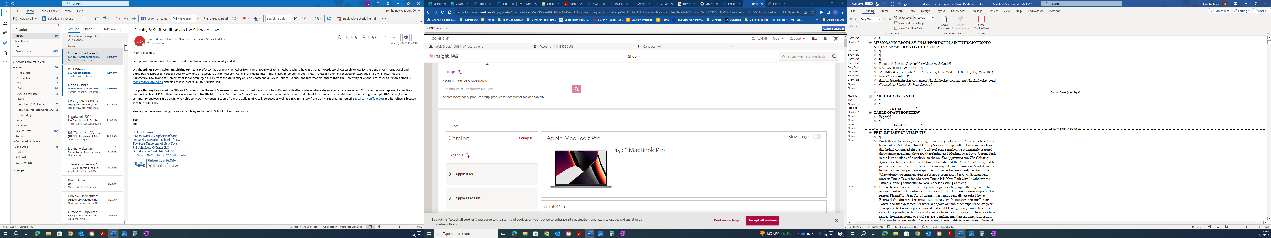

- Use the button mentioned above to create the ToC. If you skipped the steps above, you’ll get a message. Then the ToC box will appear without entries.
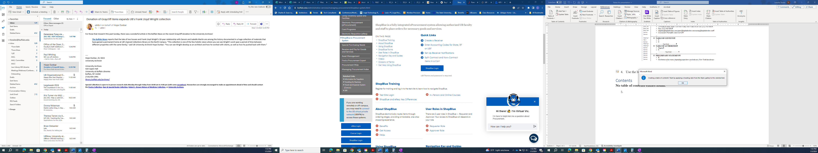

- If you used the proper styles, the ToC will appear like this: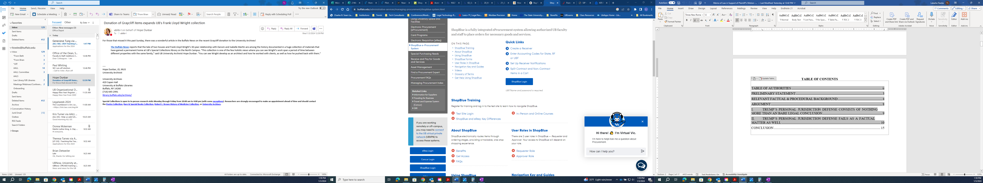
- When creating a ToA, you’ll need to mark the citations throughout the document. Under the References tab in the Table of Authorities section you’ll find the Mark Citation button; the dialog box will open as shown.
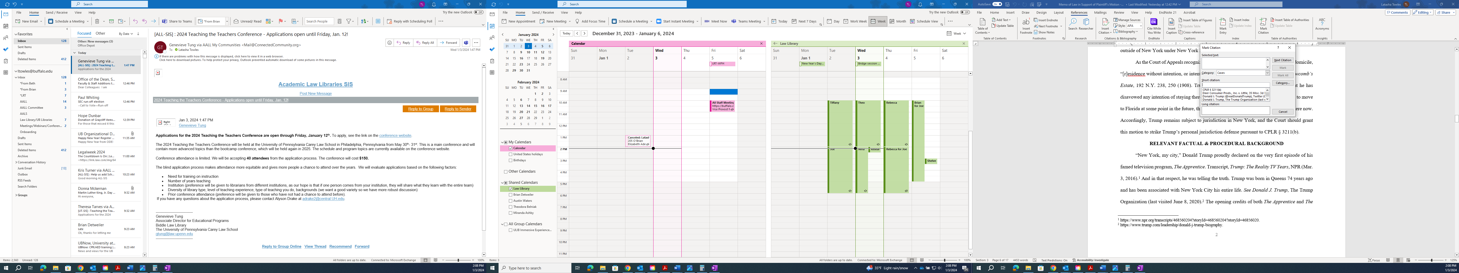

- Go to the first citation in the document and mark it for the table. Ensure the category matches the type of document, in this instance ‘Cases’ is the correct category. Click Mark, then Next Citation.
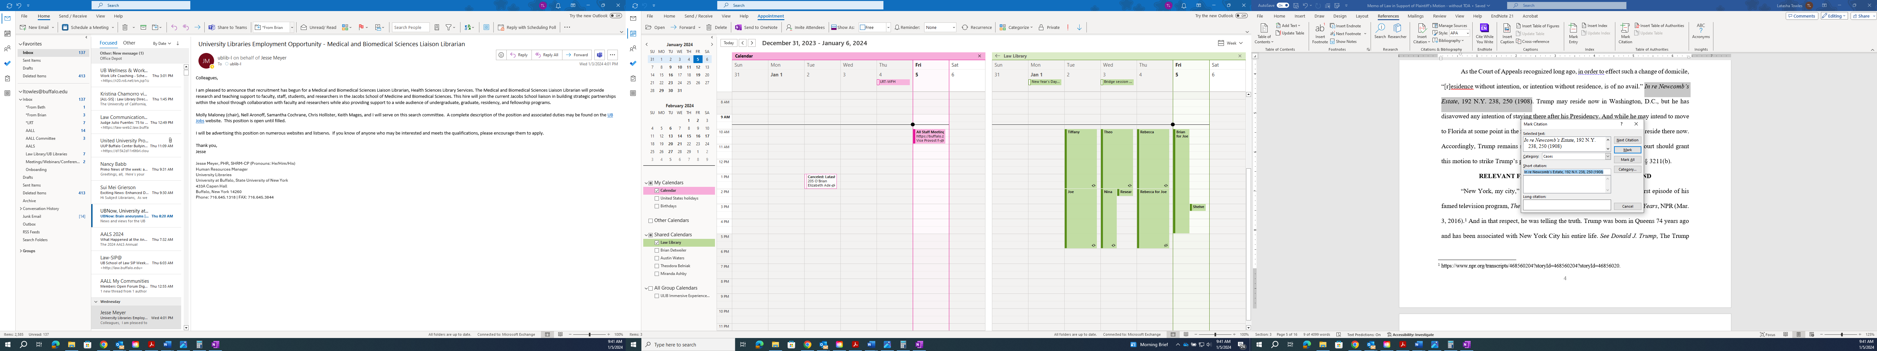

- For repeat, shorter citations, you’ll do the same process, but you’ll need to match it to the previous full citation, so they all appear correctly in the table of authorities.
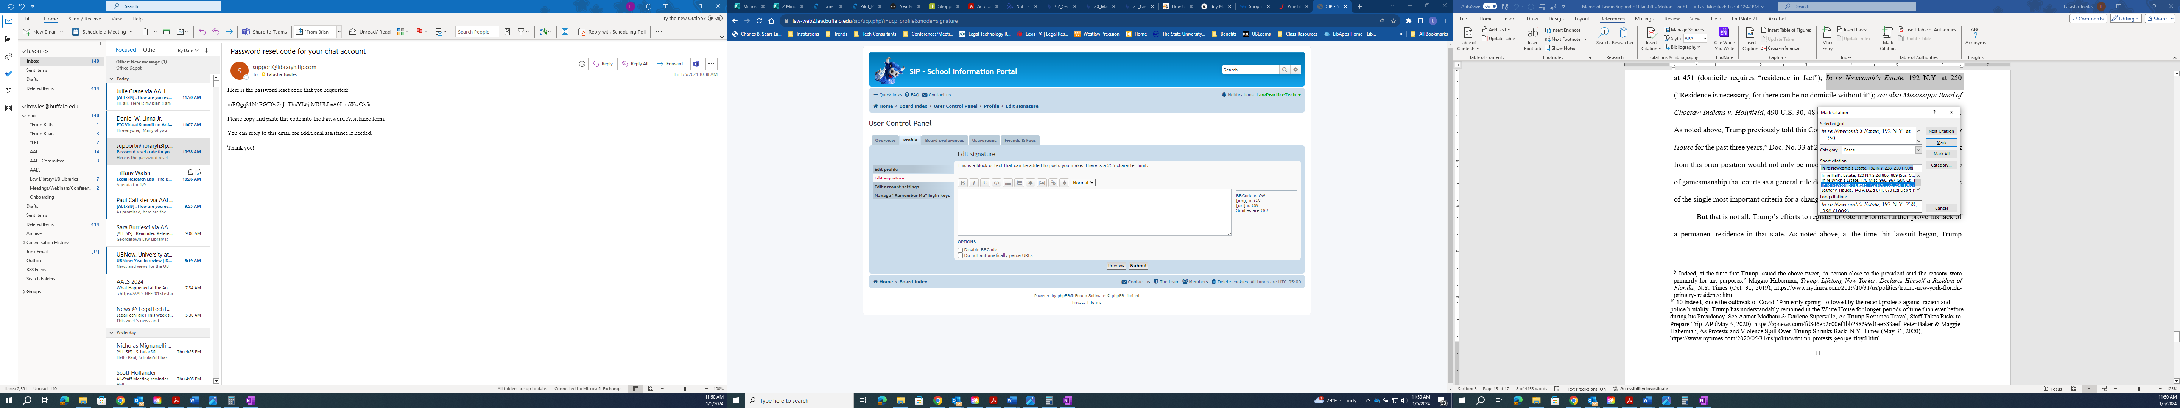

- After you have marked all the necessary citations, you can create the table of authorities.
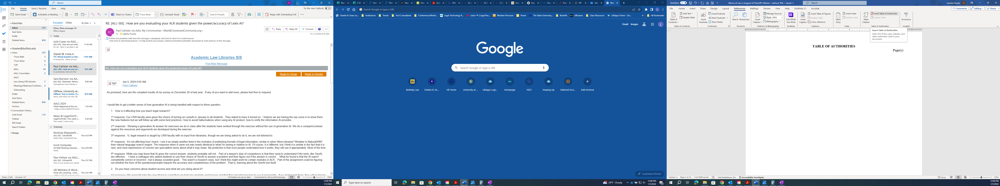

- To ensure you have marked all the citations, turn on the Show/Hide (Home tab) and check that all the citations have been marked.
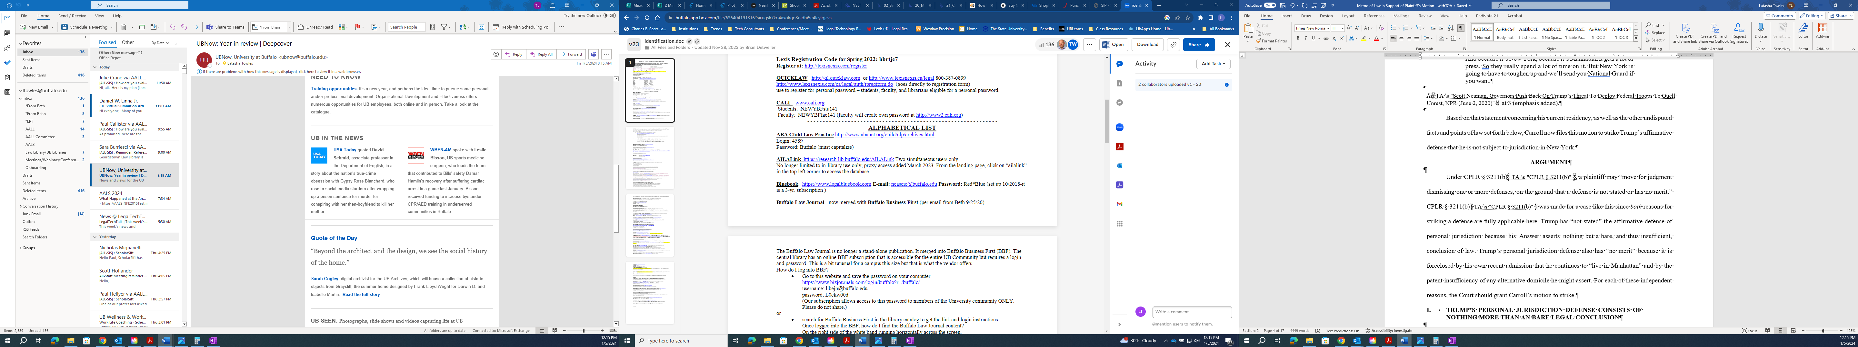

- Table of Authorities
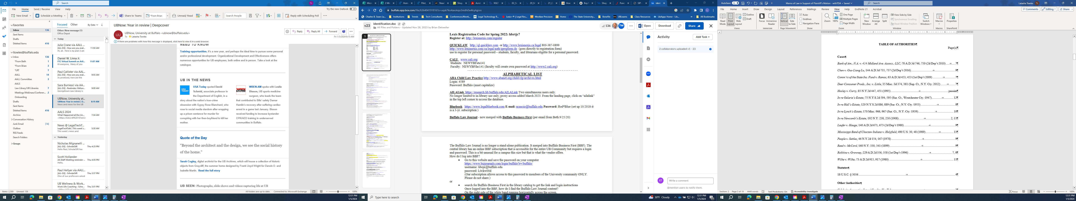
      - To insert bookmarks, put the cursor near the section you want to bookmark (text, picture, location). Click the Bookmark button on the Insert tab.

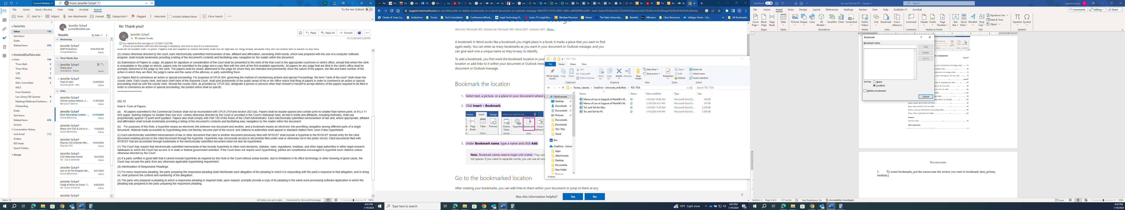

      - Next, enter the name of the bookmark and click add.

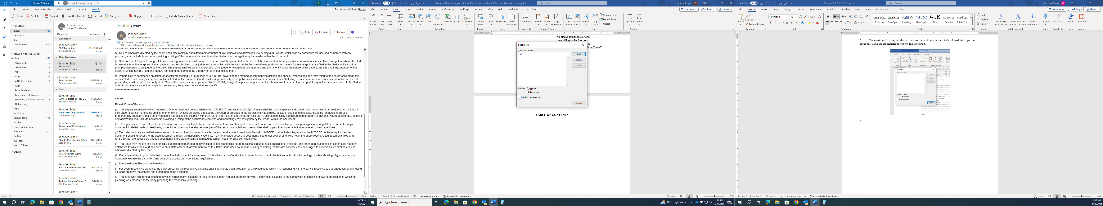

      - Repeat these steps for all the bookmarks you want to add. Then check to ensure the bookmarks go to the proper location.

  - One way to do this is to click the Bookmark button and choose the name, then click Go To. It should jump to the place you put the cursor when creating the bookmark.

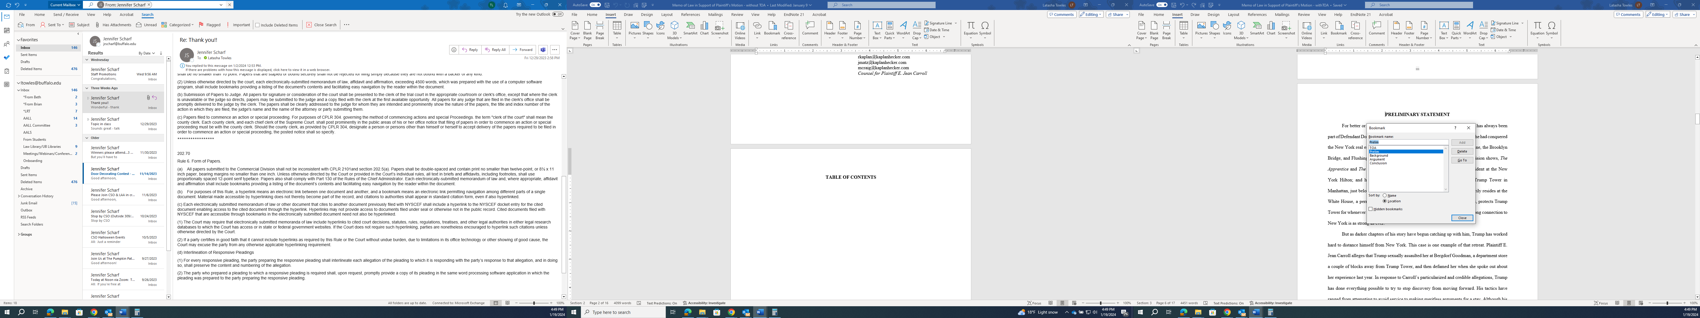

  - Another way is to use Ctrl + G. The Find and Replace dialog box will open on the Go To tab. Use the arrow to extend the menu and choose the bookmark you want. Then click Go To.

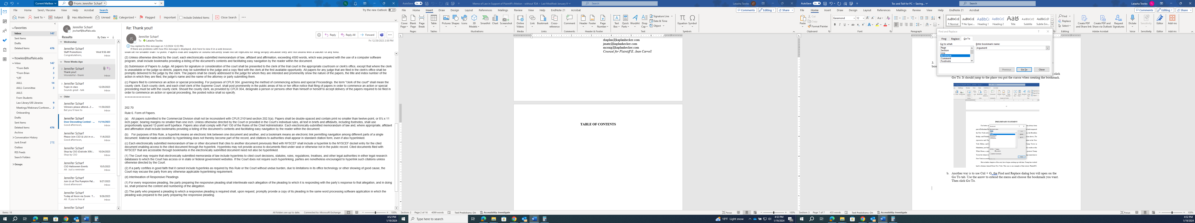

  - An additional way, go to File, Options, Advanced and then scroll to ‘Show document content” and select Show Bookmarks. Brackets will show up on both sides of where you created the bookmark.

